April 30th, 2006
Hi Gavin and Nadine
Have written more in my diary this past week, but it may not translate into a longer letter.
I have started swimming for the season. I went five days last week, doing 1 km for the first four days and a bit more on Friday giving 6.3 km for the week. I have also been going earlier in the mornings to avoid the strong UV light at midday. In fact, for three days it was so cloudy that the UV reading was so low that I didn’t need any sunscreen lotion. Put it on for the other two days. The HK Observatory has a website for the local weather and this includes a graph of the UV readings which are updated every 15 minutes. So I have set up an icon on my computer so I can quickly check the latest UV reading at any time.
Because of swimming, I did not go to the gym last week. Also, my running season is completed and even though yesterday was a bit cooler and suitable for a run, I still did not go.
On Monday night and Tuesday morning, there was very heavy rainfall on parts of HK Island. They got about 200 mm (8 inches) on rain in a short time. The Observatory estimated that such a downpour would only occur once in 400 years. They had to estimate as they only have actual records of rainfall going back 120 years or so.
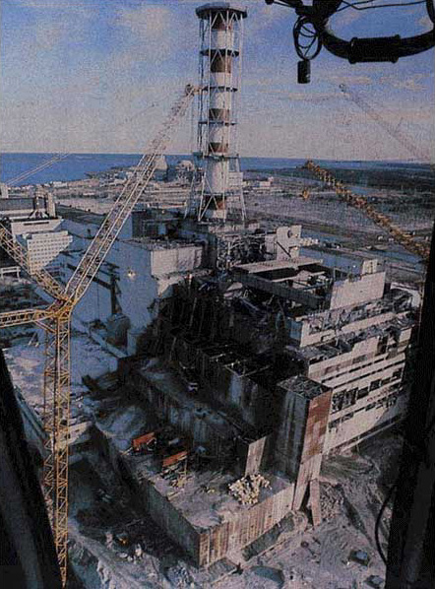
Tuesday was also Anzac Day. The Australian TV channel broadcast live the dawn service at Gallipoli in Turkey. I watched it. There were a lot of people there, especially young Australians, nearly all of who seemed to be wearing gold and green (Australian colours) woollen beanies. On the same day, there was another terrorist bomb explosion in Egypt. This was at Dahab, quite close to the previous attack about a year ago. If I had gone on the full bus trip in Egypt, I would have gone to Dahab. But, as that would have meant a stay of about 5 days, I skipped that tour.
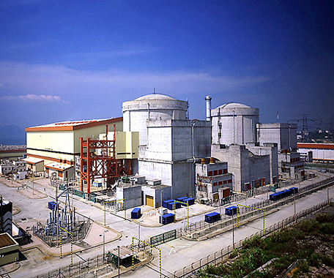
Wednesday was the 20th anniversary of the nuclear accident at Chernobyl, in the Ukraine (which was part of the USSR then). That night there was an interesting TV documentary re-creating the events and using the actual control room at Chernobyl which was not damaged in the explosion. I remember the concern in HK at the time, as the Daya Bay nuclear power station was being built in China at the time, just over the hill at the far end of Tolo Harbour. That meant that if there was an accident at Daya Bay, the radiation would reach the Chinese University first as the prevailing wind is from that direction!! But the Chinese reactor uses a French design which is much safer than the somewhat primitive and poorly-constructed Soviet reactors.
Exploded reactor at Chernobyl
Daya Bay nuclear power station
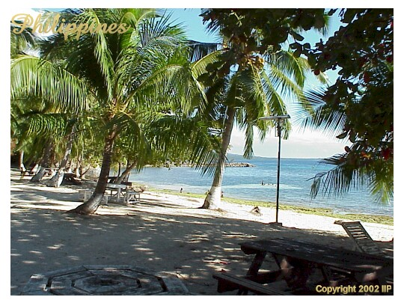
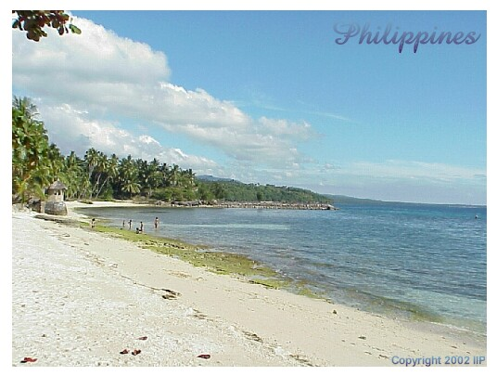
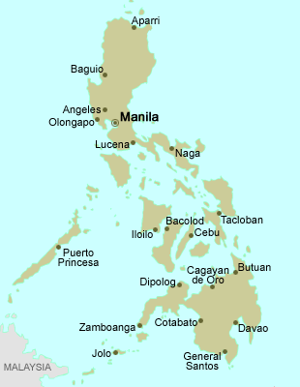
Leonie was here overnight on Wednesday as she was leaving for Cebu in the Philippines early Thursday morning with her friend Ags. They travelled on Cathay Pacific. They get back late tonight. I visited Cebu many years ago, but just for a couple of days as part of a visit to the Philippines, but didn’t go to any beaches there. (On the map, I have shown the route I took; all flying, except the dotted line, which is by car.)
to Japan
from HK
On the TV news the other night, there was a report about huge amount of Chinese fake goods in Europe. This included a fake Ferrari of a model of which only 6 were made! So the fake was number 7! The picture below is one of the 6 real Ferraris – couldn’t find a photo of the fake though there were many videos.
There has been another coal mine disaster in China. This was yesterday. The mine was wrecked by a gas explosion. Of the 39 in the mine, about 30 were killed.

Cheers.
